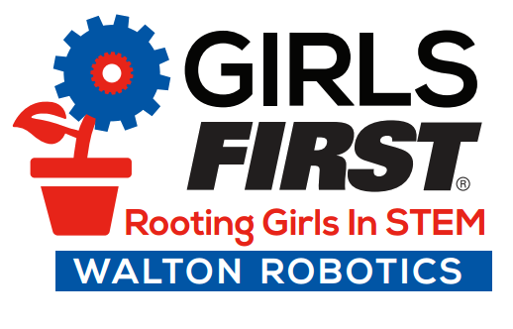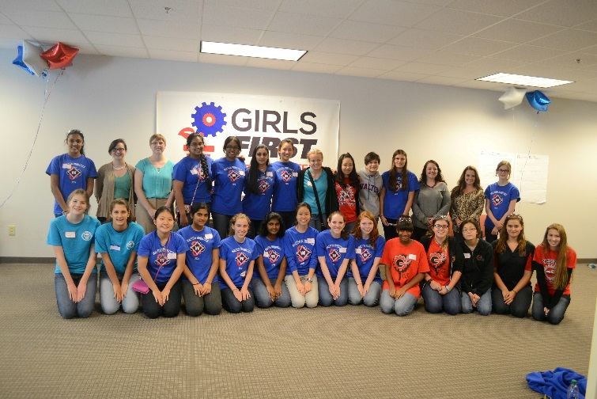

Completion of this program will enable students to:

* Articulate their skills, interests and backgrounds both written and verbally
* Differentiate themselves from other school and job applicants
* Present themselves in a professional and confident manner
* **Writing Winning Applications** – Students develop the ability to define their unique skills and interests. They participate in a selection exercise to help them understand how to differentiate themselves as an applicant.
* **Mock Interviews with STEM Professionals** – Through a series of mock interviews, students practice answers to typical interview questions and gain feedback from business professionals experienced in interviewing.
* **Reality Check Roundtable** – Students gather in small groups and articulate their future plans with a professional to assist them in planning their next steps after high school.

**January 16, 2017**

**10:00 am to 2:00 pm**

**Walton High School**

1590 Bill Murdock Road, Marietta, Georgia 30062

**Interview & Application Workshop for Girls**