FIRST ® LEGO® League
Team Tournament
Information Packet

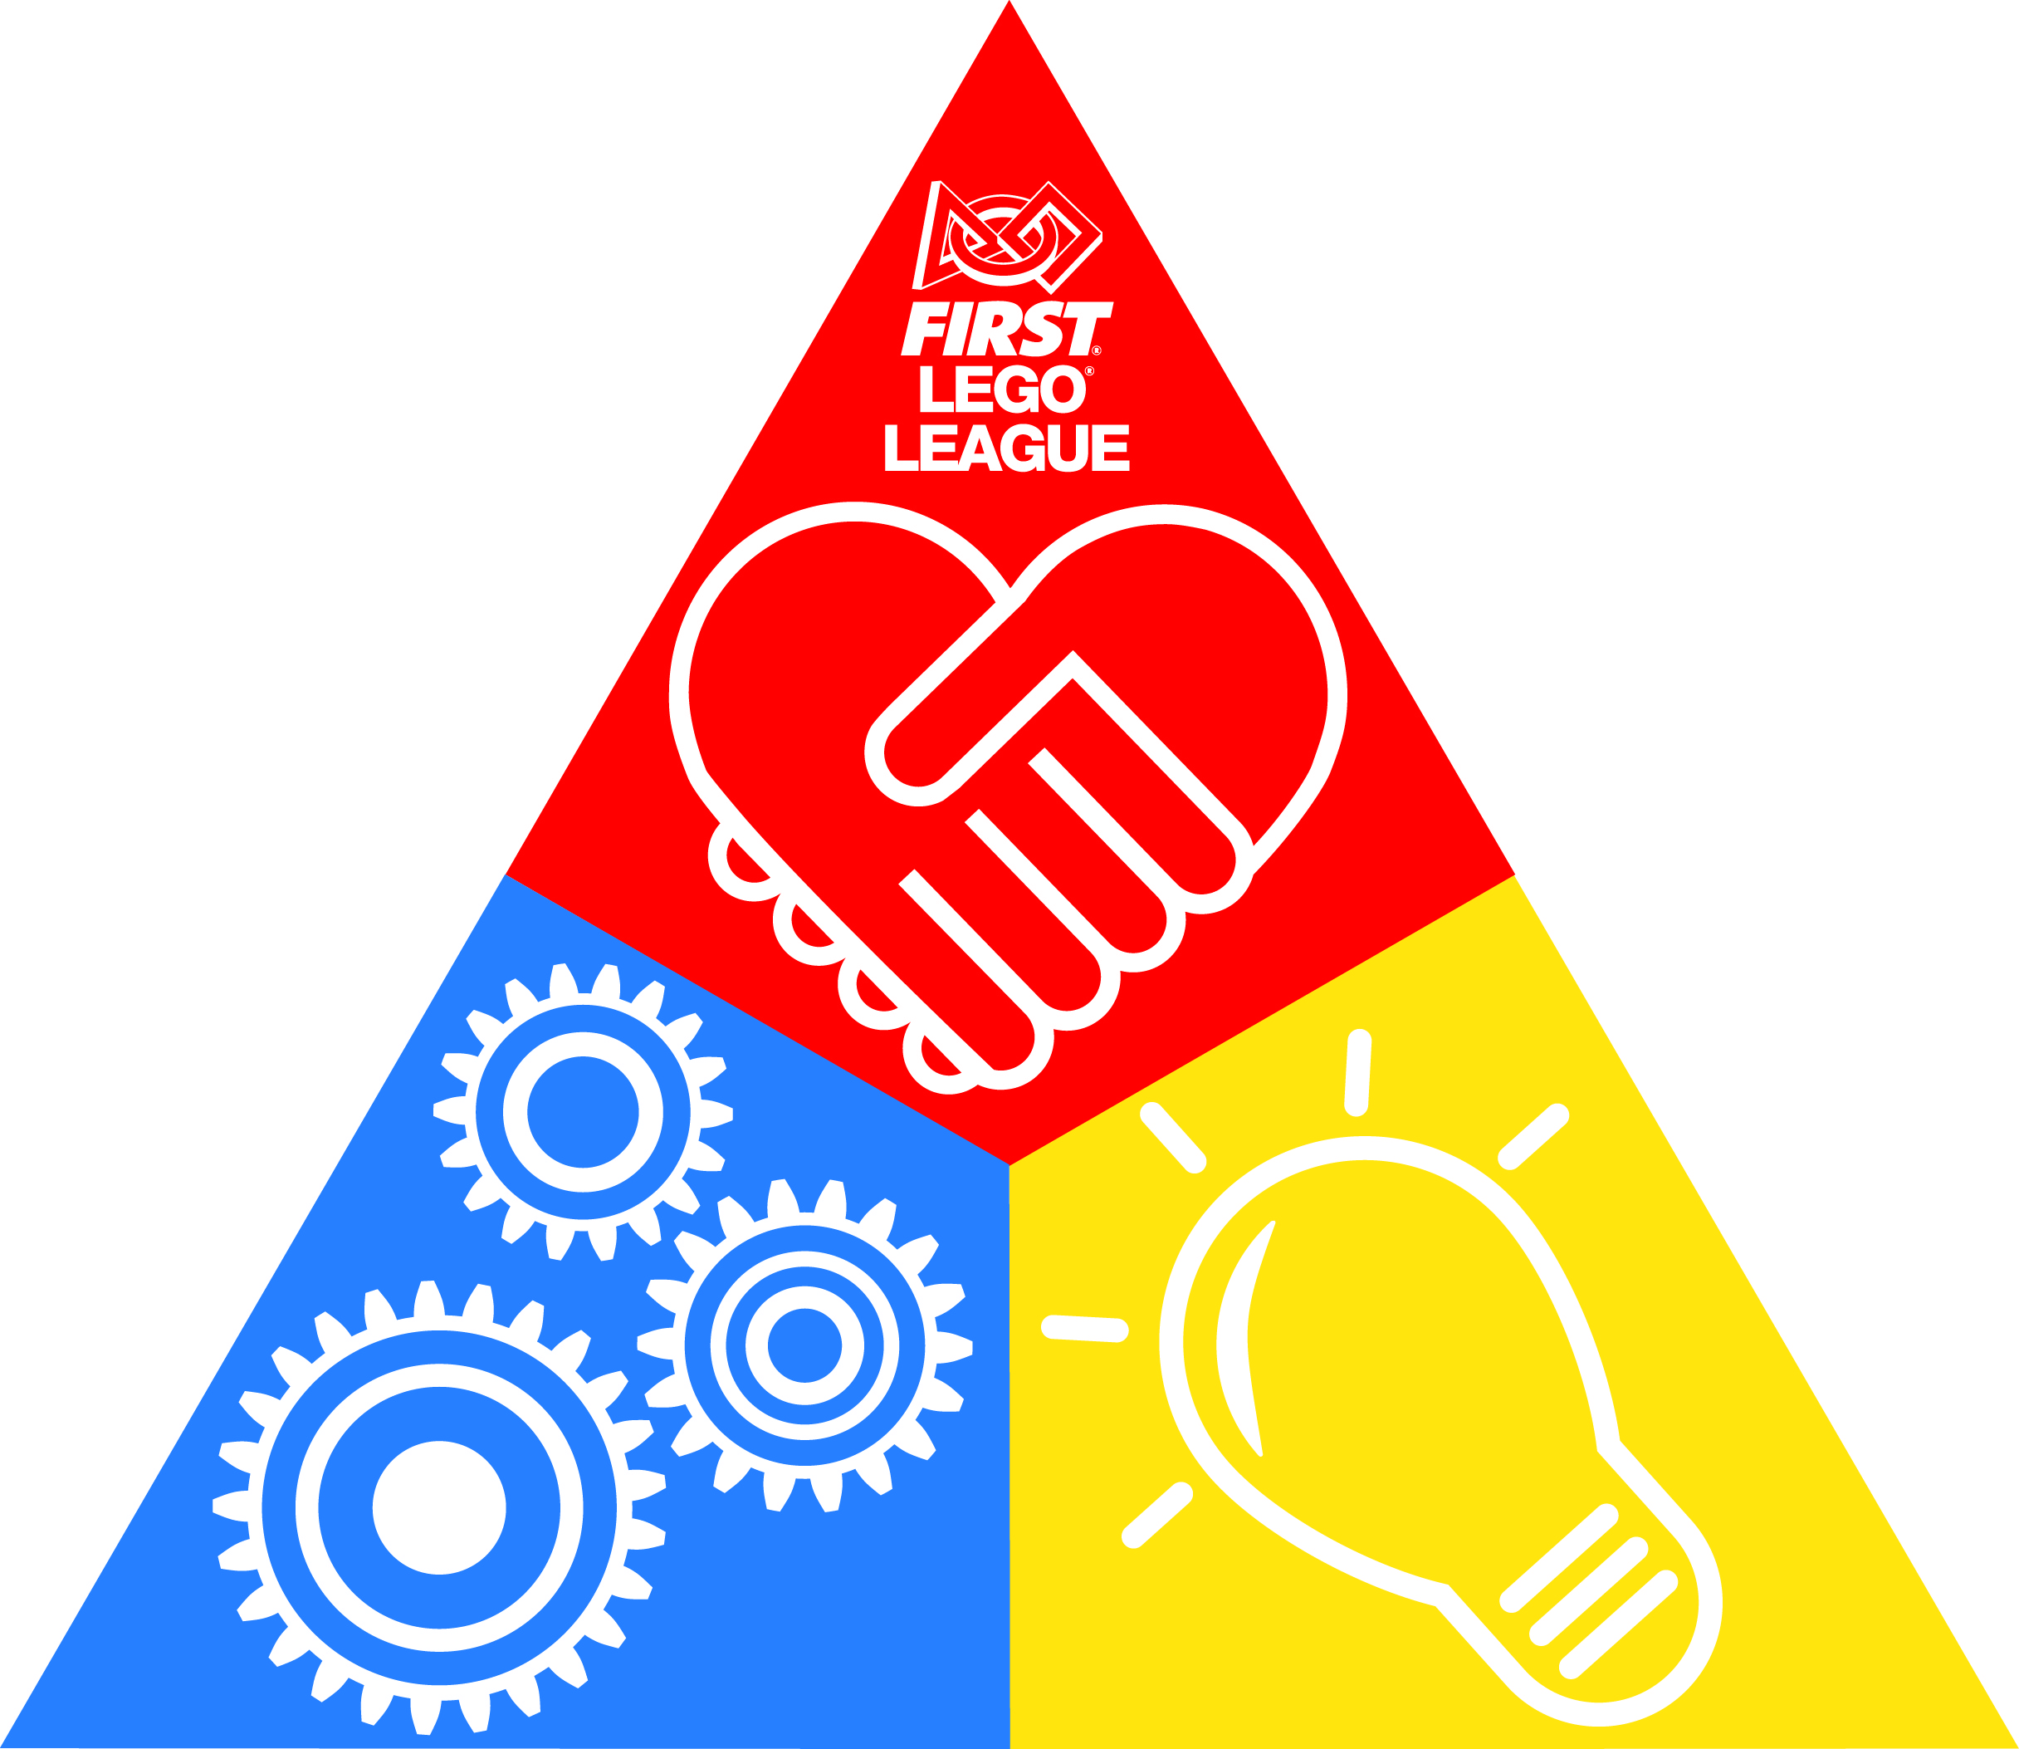

Table of Contents
Tournament Date, Time, Location and Contact 3
Basic Schedule 3
Directions 4
Parking 4
Food 7
Dress 6
Team Size 9
Team Check-in 9
Pit Area 9
Coaches’ Meeting 11
Judging 11
Robot Design Judging 13
Project Judging 13
Core Values Judging 13
Opening Ceremony 13
Spectators 13
Robot Game 14
Awards 14
Championship Advancement 15
What is Gracious Professionalism®? 15
Tournament Cancellation Policy 15
Competition Day Checklist 16

Walton Robotics Regional

FIRST® LEGO® League Qualifier

Tournament Date, Time, Location, and Contact

Date: December 9, 2023
Time: 8:00 AM – 4:30 PM
Location: Walton High School Dining Hall, 1590 Bill Murdock Rd, Marietta, GA 30062
Tournament Contact: Stephanie Morgan Stephanie.Morgan@Waltonrobotics.org

Basic Schedule (Not Finalized)

Time | Activity
8:00 AM | Team Check-in & Pits Open
8:30 AM | Coaches Meeting
8:50 AM | Opening Ceremony
9:15 AM | Judging and Matches
10:45 AM | Break
11:00 AM | Judging and Matches resume
12:30 PM | Lunch
1:00 PM | Matches Resume
2:00 PM | Break
2:15 PM | Matches Resume
3:15 PM | Pit Break Down, Clean Up and Deliberations
4:00 | Awards Ceremony

Directions

Walton High School is located north of I-285, east of I-75 and west of GA400. Turn into the bus entrance, which is the entrance closest to the Bill Murdock Rd and Pines Rd intersection. There will be an unloading zone marked near the tournament entrance and then after you have unloaded you will park in the parking lot behind the school in the bus lanes. You will enter the tournament via the doors to the Dining Hall as illustrated in the picture below. It is important that all attendees enter through the external Dining Hall doors as illustrated. The ACT is taking place at Walton this same morning and it is imperative that no one interferes with testing. Please pass this information on to your parents and any other spectators that may want to attend. Teams will be disqualified for being outside the designated areas inside the school. Thank you for your understanding the importance of this.

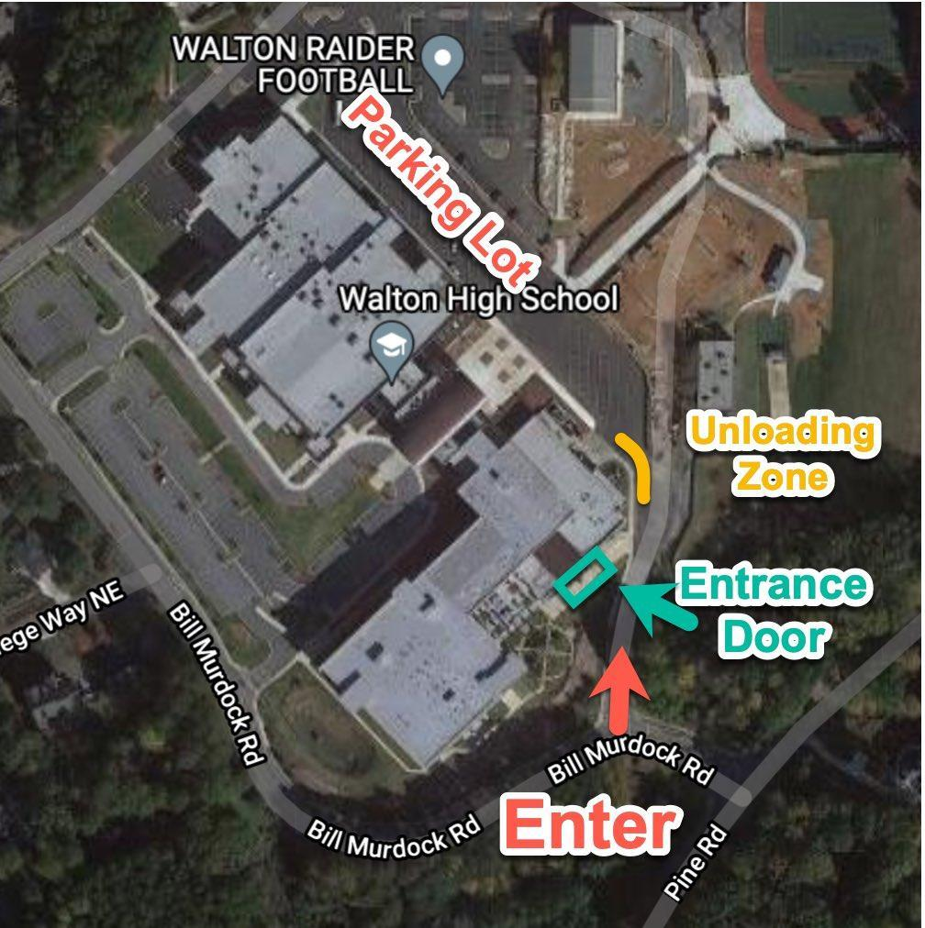

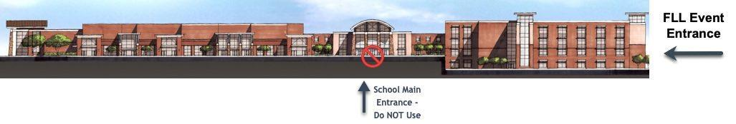

FLL Event Entrance:
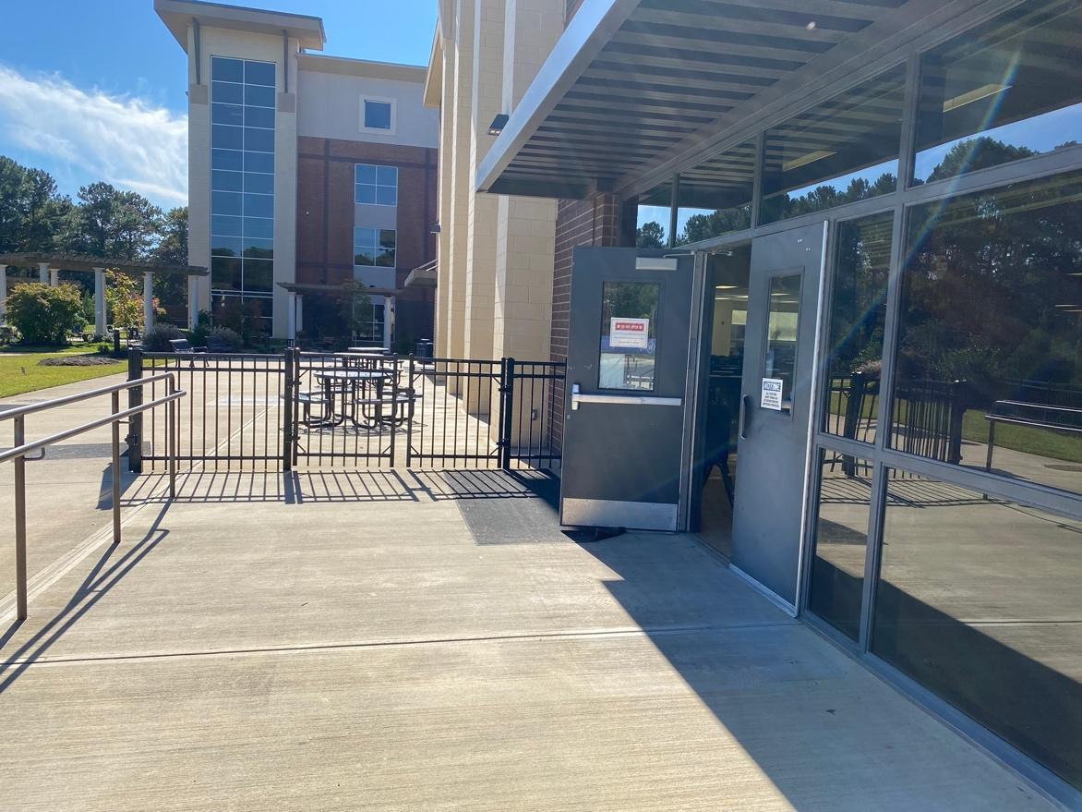
FLL Loading Zone:
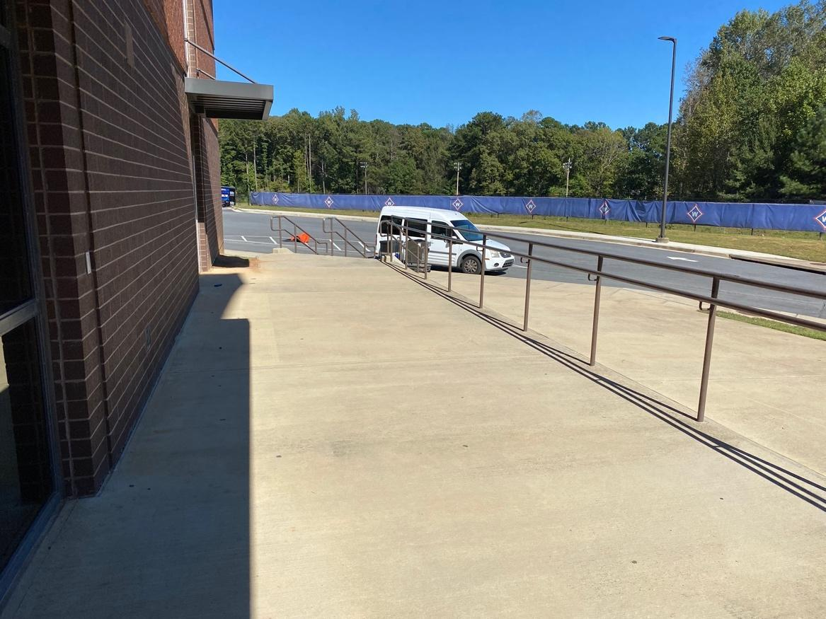

Coming South on I-75 from I-575 and Kennesaw:

Exit I-75 South at N 120 Loop (Exit 265)

Turn left at bottom of exit ramp onto the 120 Loop

Follow the Loop to the Roswell/Marietta Exit (first actual exit ramp you see)

Turn left onto Hwy.120

Follow Hwy. 120 to Providence Road (after Old Canton road stoplight)

Make a left onto Providence Road

At first stop sign, turn left onto Pine Road

Next stop sign, turn left onto Bill Murdock Road

Follow FLL signs to the parking area.

Coming North on I-75 from Smyrna and I-285:

Exit I-75 North at S 120 Loop (Exit 263)

Turn right at end of exit ramp onto the 120 Loop

Follow the Loop to the Roswell/Marietta Exit (first actual exit ramp you see)

Turn right onto Hwy. 120

Follow Hwy. 120 to Providence Road (after Old Canton road stoplight)

Make a left onto Providence Road

At first stop sign, turn left onto Pine Road

Next stop sign, turn left onto Bill Murdock Road

Follow FLL signs to the parking area.

From GA400 and I-285 area:

Go west on I-285 Exit I-285 at Riverside Drive (Exit 24)

Go north on Riverside Drive. Follow many curves on Riverside Drive until the stoplight at Johnson Ferry Road (large intersection at bottom of twisty hill)

Turn left onto Johnson Ferry Road heading north

Turn left onto Roswell Road (Hwy. 120) (You will pass Lower Roswell Road...different road so keep going)

Turn right onto Providence Road (at Advanced Auto Parts and Fifth Third Bank)

Turn right at first stop sign onto Pine Road

Turn left at next stop sign onto Bill Murdock Road

Follow FLL signs to the parking area.

From Northern GA400:

Exit GA400 South at Holcomb Bridge Road (Exit 7)

Turn right (west) onto Holcomb Bridge Road

Turn left onto Highway 9 (Chick-fil-A is on your right)

In downtown Roswell, turn right onto Hwy. 120/Marietta Highway (at the Roswell Square)

Follow Hwy 120 into Cobb County to Johnson Ferry Road

Continue past Johnson Ferry Road to Providence Road (next stoplight)

Turn right onto Providence Road (at Advanced Auto Parts and Fifth Third Bank)

Turn right at first stop sign onto Pine Road

Turn left at next stop sign onto Bill Murdock Road

Follow FLL signs to the parking area.

Food

Concessions will be available in the Dining Hall where teams can buy breakfast and lunch. The concession menu will likely be as follows:

Menu:
- Breakfast
  - Donuts
  - Fruit
  - Coffee/tea/water

- Lunch (Please Note this is scheduled for 30 minutes)
  - Pizza (See preorder form below)

- Drinks
  - Water
  - Soda
  - Gatorade

Lunch Preorders:
If you would like to pre-order lunches for your FLL team, please fill out the Google Form below by November 30th at 5pm to ensure that your team will be able to order lunch.
https://forms.gle/F6ci1dWb1rhyAEjg8

A variety of nearby restaurants (within 2-3 miles from venue) are listed below for your convenience. Please be aware that lunch is only scheduled for 30 minutes. Please prepare accordingly.

Food is permitted only in the Dining Hall and the adjacent outside courtyard.

Teams can bring their own food and drinks as well as coolers.

Nearby Restaurants:
Johnny’s Pizza  Parkaire Landing Shopping Center  4880 Lower Roswell Road  Strip mall behind Taco Bell  Thin- & thick-crust pies & Italian fare  Phone: 770-578-6606 | Capozzi's Pizza  East Cobb Crossing Shopping Center  4285 Roswell Rd  No-frills joint for NYC-style pies  Phone: 770-321-5550
Domino's Pizza  Pizza Delivery · 4724 Lower Roswell Rd Ste 101  Phone: 770-641-7020 | Papa John's Pizza  Pizza Delivery · 4811 Lower Roswell Rd  Phone: 770-971-1411
Chin Chin Chinese Restaurant  Restaurant · 617 Johnson Ferry Rd  Chinese standards in relaxed digs  Phone: 678-560-5550 | Hong Kong Star Chinese Cuisine  Chinese · 4719 Lower Roswell Rd #110  Snazzy spot for classic eats & cocktails  Phone: 770-509-2129
Publix Super Market  East Cobb Crossing Shopping Center  4269 Roswell Road  (770) 579-1620 | Panda Express  Restaurant · 4275 Roswell Rd  Simple Chinese fast-food chain  Phone: 770-509-6708
Whole Foods  Merchant's Walk  1311 Johnson Ferry Rd #580,  Marietta, GA 30068  Phone: 678-996-9700 | Panera Bread  The Avenue East Cobb, 4475 Roswell Rd Bakery/cafe chain with free WiFi Opens at 7:00 AM Phone: 770-565-5338
Subway  Providence Square Shopping Center  4101 Roswell Rd, Suite 903  Build-your-own sandwich chain  770-578-4457 | Cava  4400 Roswell Road  Mediterranean Cuisine with fresh wraps and bowls  (470) 524-0237
Chick-fil-A  Woodlawn Square  1201 Johnson Ferry Rd  Phone: 770-565-4653 | Which Wich design-your-own sandwiches  1401 Johnson Ferry Rd Suite 310,  Marietta, GA 30062  Phone:770-321-9424
Chipotle Mexican Grill  Fast-food chain offering Mexican fare.  Merchant's Walk,  1281 Johnson Ferry Rd  Phone: (678) 279-1604 | Wendy’s  1312 Johnson Ferry Road  Fast food, Hamburgers and Frosties
Starbucks at Target  1401 Johnson Ferry Rd  Phone: 770-240-0005 | Starbucks  Woodlawn Shopping Center  1207 Johnson Ferry Rd  Phone: 770-578-8009
Zaxby's Chicken Fingers & Buffalo Wings  750 Johnson Ferry Rd  Casual chain for chicken finger platters  Phone: 678-560-8100 | Dunkin’  980 E Piedmont Road  Coffee and Doughnuts

Dress

Dress for all teams is casual. In fact, we encourage your team to adopt a fun and unique team identity which allows others to understand something about your team, your engineering experience, or your project. Think smart marketing! Remember to HAVE FUN!

Team Size

The maximum number of children on your team is 10. Please email the Tournament director to let her know how many team members are on your team as soon as possible. All members of your team must be between the ages of 9 and 14 years. For the upper limit, no student can be older than 14 years of age as of January 1 of the Challenge year. Your team will need to decide what two adults will be spending the day with the students. NOTE: At least one adult Coach is required to supervise the team at all times during the tournament. Please remember to tell us how many members are on your team.

Team Check-in

Team Check-in will be from 8:00 AM – 8:30 AM.
Coaches must submit the following for their teams to the Team Check-in Volunteers:
- Team Roster: Download your team roster from the Team Registration System, print a copy, and bring it to Team Check-in. Staple additional FIRST® Consent and Release Forms to the Team Roster for any team member or coach who does not have an electronic consent form on file. A FIRST Consent form is required for every team member, coach, and mentor who will be with the team during the competition day.
- Team Information Sheet: Please bring two completed copies of the Team Information Sheet. Your team will deliver a copy of your Team Information Sheet to your judging panel when you attend your judging session. Judges use the sheets to learn about the teams, find out about their strengths, and use the information in the judge deliberation process. As teams fill out their Team Information Sheet they are highly encouraged to include an accurate team photo, ideally with members wearing their team shirts/outfits. Judges see a lot of teams throughout the day. An accurate photo allows judges to easily associate the unique qualities a team presents alongside a visual reminder of the team.
Your team will receive the following at Team Registration:

Team Packet: Your team will be provided information about the tournament day, including a competition schedule, judging schedule, and Pit map.

Pit Area

The Pit is where your team will spend most of the time. This is where you will work on your robot and programming. This is also the area where you can enjoy downtime with your team, get to know other teams, see their robots, and find out about their Projects. Your team will have access to:
- One cafeteria table
- At least 8 chairs
- Electricity – Bring an extension cord and a power strip, as your access point will consist of a single outlet/plug. A power strip will allow you to charge your robot and your laptop at the same time.
We recommend that you bring the following for your team to have in the Pit Area:
- A bin or large bags (like trash bags) to store personal belongings, like coats, under your table
- Your robot and all your robot supplies (attachments and additional building pieces)
- Your laptop computer and power cord
- An extension cord and power strip
- A small box or small bin to carry your robot and attachments to and from the competition area. No carts allowed this year.
- A team display board
- A team banner or other team sign – to hang from your pit table and carry for Opening & Closing Ceremonies (Optional)
- Games (there will be long periods of downtime – bring some small games that the team can play when things are slow)
- Items to share with other teams (optional) – At many tournaments, teams bring something little that says something about their team that they can share with other teams (ex. A team might pass out Kiss candies with a note to remind teams about the K.I.S.S. principle, “Keep It Simple, Silly.”) Or whatever else you would like to share that says something about your team, your school, your project, your robot, etc.
Some Pit Area Rules for you to keep in mind:
- Coaches should NEVER work on the robot, the attachments or the robot programming. In fact, coaches should refrain from handling the robot, attachments or the computer – save your internet surfing for another time. NOTE: If your team encounters technical difficulty, let someone at the tournament know so that the officials at the event understand why a coach might need to handle a robot or work on the computer.
- There will not be available WIFI on the day of the event due to ACT testing. The cellular connectivity at the school is spotty as well. Please make sure you download all important needed information prior to the event.
- Remember to be Gracious Professionals when using the practice table:
  - Be mindful of your time and other teams’ needs (In the event that another team has a crisis with their robot - robot repairs, loss of firmware, etc.- please be courteous and allow a team facing a crisis to use your practice time).
  - Reset the practice field for the next team
  - Make sure you check that you do not take a mission model from the practice field
  - Offer help to teams that may need it!

Coaches’ Meeting

The Coaches’ Meeting will be held in the Competition Area at 8:30 AM. At least one team coach should attend this meeting. Make sure that another coach or mentor is assisting the team to set up their Pit area during this time. At this meeting, your team’s coach will have the opportunity to:
- Meet the Tournament Director
- Meet the Head Referee
- Understand the flow pattern through the competition area
- Ask judging-related questions
- Ask robot game questions
- Ask any other tournament-related questions

Judging

Team judging begins at 9:15 AM. Your team will spend 25 minutes with the panel of judges. You will have at least 15 minutes between judging/robot game sessions.
Only team members and 2 coaches will be allowed into the judging room. One team coach will be permitted to videotape the judging session; however, that adult should remain in designated areas. Nobody from the team should stand behind the judges. Coaches should be silent observers of the judging process and refrain from influencing the session in any way. If you choose to use a PowerPoint presentation, you will have to use your own computer. You will also need your own projector if you want to enlarge the presentation. The judging schedule is tight. You must be on time for your judging sessions or forfeit the session.
All cell phones (team members & coaches) must be silenced during the judging sessions.
The teams will have one 25-minute judging session instead of 3 individual judging sessions. This will provide more flexibility for your team to present. Below are the suggested time periods per subject, but these are only guidelines. It is up to the team how much time they spend on each element of the judging material.
The following outlines what you can expect in each of the judging sessions.

Robot Design Judging

Your team will have a suggested 5 minutes to deliver your Robot Design presentation. This presentation should explain why they designed their robot the way they did. The team should be prepared to present your Robot Design Executive Summary (as outlined in the Robot Design Executive Summary document)..
You must bring your robot, its manipulators, and a diagram
or a printout of your programming to Judging!

Innovation Project Judging

Your team will have a suggested 5 minutes to deliver your Innovation Project presentation to the judges – this includes set-up time. This presentation should be rehearsed and polished. The judges will wait until your presentation is over to ask questions. Props and costumes are permitted, and judges will look for creativity in the presentation style. A standard 110v outlet will be available in the Judging Room for your AC powered devices.
Remember, to be eligible for a FIRST LEGO League Project award, your team needed to identify a problem relating to the theme, design an innovative solution to the problem you selected, and share your problem and solution with others.

Core Values Judging

Your team will have a suggested 3 minutes to demonstrate how the team reflected the Core Values throughout the season. (You will NOT be given a surprise task to complete in front of the judges, so have a presentation planned.) The judges will be looking for evidence of your team dynamics: How well does your team communicate? Do they respect each other? Do they incorporate each other’s ideas into the solution? Does your team have leaders? Do they incorporate elements of Gracious Professionalism® in the way they communicate with each other?
The final 8 minutes are reserved for the judges to ask the team questions.

Opening Ceremony

Join us for the Opening Ceremony at 8:50 AM! This is a fun celebration to open the tournament. The ceremony will include the introduction of your team so please have your team together and ready to stand when their team name is called.

Spectators

The Robot Game is free and open to the public. The Robot Games will happen in the Dining Hall at Walton High School. The judging sessions are closed to the public and will be held in classrooms. Thank you for respecting this policy. Please remember to respect the Team Only areas – the competition floor area (the area where teams queue and compete) and the judging areas.
Please also remember that the SAT is being given at the school during our event. Please let your team, friends and family know that they are allowed in the designated areas on the first floor only. If anyone is found beyond the first floor area, their team is subject to disqualification.

Robot Game

Your team is responsible for knowing and understanding the FIRST® LEGO® League Robot Game. All of the game documents can be found on the FIRST LEGO League website.
You are required to know the following for the robot competition: Field Setup, Rules, Missions, and Robot Game Updates.
Housekeeping: Please keep the Pit area clean and follow the Practice Table schedule. Due to the size of the Home/ Landing area, no carts or bins will be allowed near the game tables.
Coaches: No coaches or parents are allowed near the competition table. Please do not touch or handle the robot or attachments during this time.
Your team will participate 5 times at the competition tables.Only the team’s best score of the three matches counts toward awards and advancement. Ties are broken using second and third best scores
NOTE: Remote controls are not allowed anywhere at this tournament (This includes Smartphone applications that enable you to control your robot remotely). Bluetooth may not be used. Your team could be disqualified if you are found remotely controlling your robot anywhere during the competition or if your Bluetooth is enabled in the competition area!
Make sure you are ready to compete at least 10 minutes prior to your scheduled robot round. Remember to respect the referees and the other teams – and HAVE FUN!

Awards

The Awards ceremony will include a parade of teams. Please ensure that your team is ready to show how proud they are to have participated in this event.
The following awards will be presented at this tournament:
- Champion’s Award
- Robot Design Award
- Core Values Award
- Innovation Project Award
- Robot Performance Award

Championship Advancement

Super-Regional advancement is posted to the Tournament Assignments page by the Wednesday after each Regional or once results have been received and verified. It is the responsibility of the coach to check the Assignments page to see if their team has advanced, no email will be sent until the host contacts the participating teams.

What is Gracious Professionalism®?

Gracious Professionalism® is part of the ethos of FIRST®. The idea and phrase are found throughout FIRST, but no one has been a stronger champion than FIRST National Advisor, Woodie Flowers.
“Gracious Professionalism is a way of doing things that encourages high-quality work, emphasizes the value of others, and respects individuals and the community. With Gracious Professionalism, fierce competition and mutual gain are not separate notions. Gracious Professionals learn and compete like crazy, but treat one another with respect and
kindness in the process.”
We expect all team members, volunteers, coaches, and families to behave as Gracious Professionals.

Tournament Cancellation Policy

The Walton Regional qualifying tournament may be canceled or delayed due to causes and conditions beyond the tournament organizers’ control, including, but not limited to inclement weather, acts of nature, government restrictions, and/or any other cause beyond the tournament organizers’ control. Please refer to local news and radio for current county advisories. If the event must be canceled, it will not be rescheduled, and advancement to the next level FIRST LEGO League Championship will be determined by lottery of teams registered for this event.

Competition Day Checklist

Team Roster
Team Information Sheets (2 copies)
Robot, attachments, extra parts
Fresh batteries/spare batteries/rechargeable battery charger
Computer and battery (if available) and power cord
USB download cable (Bluetooth use is NOT permitted at the tournament)
Extension cord and power strip
No carts allowed at Robot Game Table (Landing/ Home area sufficient to hold all parts)
Provisions for lunch
Bin to hold personal and team items (coats, games, etc.) to fit under Pit table
Project judging materials, props, and displays
Core Values Poster (Optional)
Robot Design Executive Summary
Graphics demonstrating programming strategy for Robot Design Judging
Team games or activities for downtimes (optional)
Team Banner or poster to carry for ceremonies or for Pit space (optional)
Team Giveaways (optional)
FIRST®, the FIRST® logo, FIRST® Robotics Competition, FIRST® Tech Challenge, Coopertition®, and Gracious Professionalism® are registered trademarks of For Inspiration and Recognition of Science and Technology (FIRST®). LEGO® is a registered trademark of the LEGO Group. FIRST® LEGO® League and FIRST® LEGO® League Jr., are jointly held trademarks of FIRST and the LEGO Group. All other trademarks are the property of their respective owners.
© 2017 FIRST and LEGO Group. All rights reserved.

